WELCOME to Kentucky
The Blue Grass State!

Howdy Friends
This is your friend Campbell Mercer writing to you from high upon Jerusalem Ridge overlooking the town of Rosine, Kentucky. You are living a part of American history this weekend as the Jerusalem Ridge Bluegrass Celebration enlarges and grows to include even more of the ancestral Monroe land that was originally deeded to Bill Monroe’s great, great, great grandfather in 1801 for service to the young United States of America in the Revolutionary War. This part of the farm was even farmed by Uncle Pen and was owned by Pen’s best friend Clarence Wilson. When Bill first added the banjo to the Blue Grass Boys in 1943 he chose Dave “Stringbean” Akeman from Jackson County Kentucky. Bill said later that he added “Stringbean” because he wanted to “include the sound of the 5-string banjo that he heard as a boy growing up on the farm in Kentucky” This farm may have been the first place that Bill heard a five string banjo and Clarence likely was the first banjo player that Bill heard. In Bill’s mind this farm that you are sitting, or standing on, right now may be the birthplace of the bluegrass banjo.
We call Jerusalem Ridge not only the birthplace and boyhood home of famous people like Bill and Charlie Monroe, but also the birthplace of an American art form. When you come to Jerusalem Ridge you will feel and experience the history everywhere you turn. You will see the views and hear the sounds of nature that inspired young Bill. And, you’ll experience the warmth of the Jerusalem Ridge folks.
The Jerusalem Ridge project is run by a very small volunteer army. Today, there is a core of about 15 dedicated folks who have kept the dream of the Rosine Project alive. In addition, there are about 10 wonderful local people who give tours of the birthplace of bluegrass music seven days a week but there is so much to do and we need your help too!
The new park addition is a historical diamond in the rough, but look how beautiful the volunteers have made it this year. We had twelve years to build the Homeplace side of the park…but two years ago we had only 40 days and 40 nights to carve this one from the wilderness. This year the Julie, Joby and the team have been working night and day for the past seven weeks getting ready for the 13th Annual Jerusalem Ridge Bluegrass Celebration. Heartfelt thanks to them, to you who expended so much energy and expense to support our preservation efforts, and to the musicians who keep this precious part of our American culture alive.
God Bless You All,
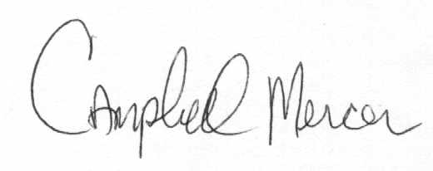
PS- We are excited to have Stringbean’s nephew, Phillip Akeman, with us this year and he is playing on Thursday with Grandpa Jones’ nephew, Phillip Steinmetz. Before “String” went to work for Bill Monroe he worked for Silas and Charlie Rogers (Si Rogers and the Lonesome Pine Fiddlers) out of Winchester, KY from 1933 on. “Stringbean” carried the song Rocky Road Blues from the Lonesome Pine Fiddlers to Bill Monroe.
Jerusalem Ridge 2014
A Great American Moment in a Great American Movement
1-270-256-1430 or 1-270-274-9181 jerusalemridgefestival.org docmercer@earthlink.net

Bluegrass from its birthplace
Jerusalem Ridge Bluegrass Celebration 2014
Wednesday October 01, 2014

12:00 - 12:50 Open Mic
12:55 - 1:45 Open Mic
1:50 - 2:40 Open Mic
2:45 - 3:15 Glenn Bolick
3:20 - 4:00 Brett Dudenhoeffer and Acoustic Essays
4:05 - 4:45 King's Highway
4:50 - 5:30 Gold Wing Express
5:35 - 6:25 Price Sisters
6:30 - 7:10 Cumberland Highlanders
7:15 - 7:55 Larry Gillis and his Swamp Grass Band
8:00 - 8:40 Gold Wing Express

Thursday October 02, 2014
10:00 - 10:10 Color Guard, National Anthem, Invocation
10:15 - 10:40 Cumberland Highlanders
10:45 - 11:00 Phillip Steinmetz and his Sunny Tennesseans
11:05 - 11:30 Ohio County Grade School Bluegrass Band
11:40 - 12:10 Phillip Akemon
12:15 - 12:45 Glenn Bolick
12:50 - 1:30 David Davis and the Warrior River Boys
1:35 - 2:15 King’s Highway
2:20 - 3:00 Phillip Steinmetz and his Sunny Tennesseans
3:05 - 3:45 Melvin Goins and Windy Mountain
3:50 - 4:30 David Davis and the Warrior River Boys
4:35 - 5:15 Alan Sibley and the Magnolia Ramblers
5:20 - 5:50 Supper Break, Special Presentation
5:55 - 6:35 Melvin Goins and Windy Mountain
6:40 - 7:25 Cumberland Highlanders
7:30 - 8:15 Blue River
8:20 - 9:00 Alan Sibley and the Magnolia Ramblers

Thanks to Our New Sponsors-
The Owensboro Animal Hospital
& Mid-South Equipment

Bluegrass from its birthplace
Jerusalem Ridge Bluegrass Celebration 2014

Friday October 03, 2014
9:00 - 10:00 Rooster Crow Warm-Up
10:05 - 10:35 Carolina Rose
10:40 - 11:20 Cumberland Highlanders
11:22 - 11:32 Cumberland Highlanders Guests
11:37 - 12:17 Phillip Steinmetz and his Sunny Tennesseans
12:22 - 1:02 King’s Highway
1:07 - 1:47 David Leatherman and Stone County
1:52 - 2:37 Tommy Brown and County Line Grass
2:42 - 3:27 Ricky Prater and the Midnight Travelers
3:32 - 4:17 Kody Norris and the Watauga Mountain Boys
4:22 - 5:02 Melvin Goins and Windy Mountain
5:07 - 5:52 Gary Brewer and the Kentucky Ramblers
5:57 - 6:12 Elvis Doolin and the Magan Square Dancers
6:17 - 6:57 Larry Gillis & His Hard Driving Swampgrass Band
7:02 - 7:42 Cumberland Highlanders
7:47 - 8:12 Steve Helton and Highlander Friends
8:15 - 9:00 Larry Efaw & the Bluegrass Mountaineers
9:05 - 9:35 Carolina Rose

Saturday October 04, 2014
9:00 - 9:55 Rooster Crow Warm-Up
10:00 - 10:40 Shane Adkins
10:45 - 11:25 Cumberland Highlanders
11:27 - 11:42 Steve Helton with Highlander Friends
11:47 - 12:27 The RidgeRunners Gospel
12:32 - 1:17 Tommy Brown and County Line Grass
1:22 - 2:02 Phillip Steinmetz and his Sunny Tennesseans
2:07 - 2:57 Rhonda Vincent & The Rage
3:02 - 3:42 David Leatherman and Stone County
3:47 - 4:37 Sammy Adkins and The Sandy Hook Mt. Boys
4:42 - 5:32 Ronnie Reno and the Reno Tradition
5:37 - 5:52 Fiddler's Roll Call
5:57 - 6:57 Larry Sparks and the Lonesome Ramblers
7:02 - 7:52 The Karl Shiflett & Big Country Show
7:57 - 8:42 Larry Gillis & His Hard Driving Swampgrass Band
8:47 - 9:32 Cumberland Highlanders
9:37 - 9:57 Cumberland Highlanders' Friends

Keeping the Dream Alive
Jerusalem Ridge Bluegrass Celebration 2014

Sunday, October 05, 2014
10:00 - 11:00 Graveside Service
11:05 - 11:35 Church Service
11:40 - 12:20 Gospel Singing
12:25 - 1:05 Shane Adkins
1:10 - 2:00 King's Highway
2:05 - 2:45 Cumberland Highlanders
2:50 - 3:40 Larry Sparks and the Lonesome Ramblers- All Gospel
3:45 - 4:35 Kody Norris and the Watauga Mountain Boys
4:40 - 5:30 Larry Gillis and His Hard Driving Swamp Grass Band
5:35 - 6:25 Karl Shiflett and Friends
6:30 - 7:30 Finale with the Cumberland Highlanders and Guests

Festival Rules:
- Keep Jerusalem Ridge wholesome – No alcohol or illegal substances are allowed. And, Ohio County is a dry county.
- Please realize that Jerusalem Ridge is operated by volunteers. Please treat them kindly. Many of them don’t even get time to listen to the music on the stage.
- Drive very slowly. Be sure to always stay to the right! Watch out for blind curves.
- If you leave your chair for extended periods expect folks needing a better view to plop down in it. They’ll be happy to move when you return.
- Please do not smoke in the concert, stage, backstage, and work shop areas.
- All campers should register with attendant before setting up. Please notify attendant if you think you have a loud generator. Quiet generators, not necessarily whisper quiet, but generators rated in the 60-69 decibel range are best.
- Please follow instructions of parking attendant. We must keep access open for emergency vehicles.
- Keep pets leashed. Friendly pets only. Please clean up after them.
- You may be on TV. It is assumed that you are agreeable to this. “Hot Set”
- Have a lot of fun!

RV Dumping $15.00 and Water Tank Refill $20.00 (Different Truck )
Call the number below when you need these services
270-685-2888
Join us Sunday Morning at 10 AM at the Rosine Cemetery for the Monroe Graveside singing and prayer service, the worship service on the main stage, and the Sunday Gospel Singing, and the Grand Finale Sunday night.

Special Thanks to
The volunteers and donors who kept the dream alive
30 Greatest Bluegrass Bands in the world
Allen Logging and Chipping
Jimmy Smith Trucking
South Central Bank
Clean Green
RFD-TV
AARP
Lizzie Lewis
The MC Team
J and J Towing
Anderson Electric
Brother Mike Taylor
Jerry and Diana Cannon
Dickey and Janice House
Monroe Home Place Tour Guides and Volunteers
And to the fans who love and support this music and its musicians

JERUSALEM RIDGE 2014 OHIO COUNTY PARK SHUTTLE SCHEDULE For help call 270-256-2550
Wednesday thru Saturday
Leave County Park Leave Jerusalem Ridge
8:30 A.M. 9:00 A.M.
9:30 (WED) 10:00
11:20 12:00
12:20 P.M. 2:00 P.M.
2:20 3:30
4:00 5:00
5:30 5:30
6:00 6:30
7:00 7:30
8:00 8:30
After last show
SUNDAY MORNING GRAVESIDE SERVICE
Shuttles will be available at the Lower Field at Jerusalem Ridge boarding area starting at approximately 9:00 Sunday morning to pick up people going to the Bill Monroe Graveside Service at the Rosine Cemetery. They will make as many trips as necessary to get all that want to attend to the site and return.

Please bear with us – if there are large numbers that want to attend by bus, some delays may be inevitable. Thanks for your patience.
PARK SUNDAY SCHEDULE
Busses will be available at the Ohio County Park at 8:15 to take folks to the Graveside Service at the Rosine Cemetery and to drop off those who want to remain on Jerusalem Ridge. The regular bus schedule to the Ridge will resume after the service at approximately 11:30 and will run until after the Finale in the evening.
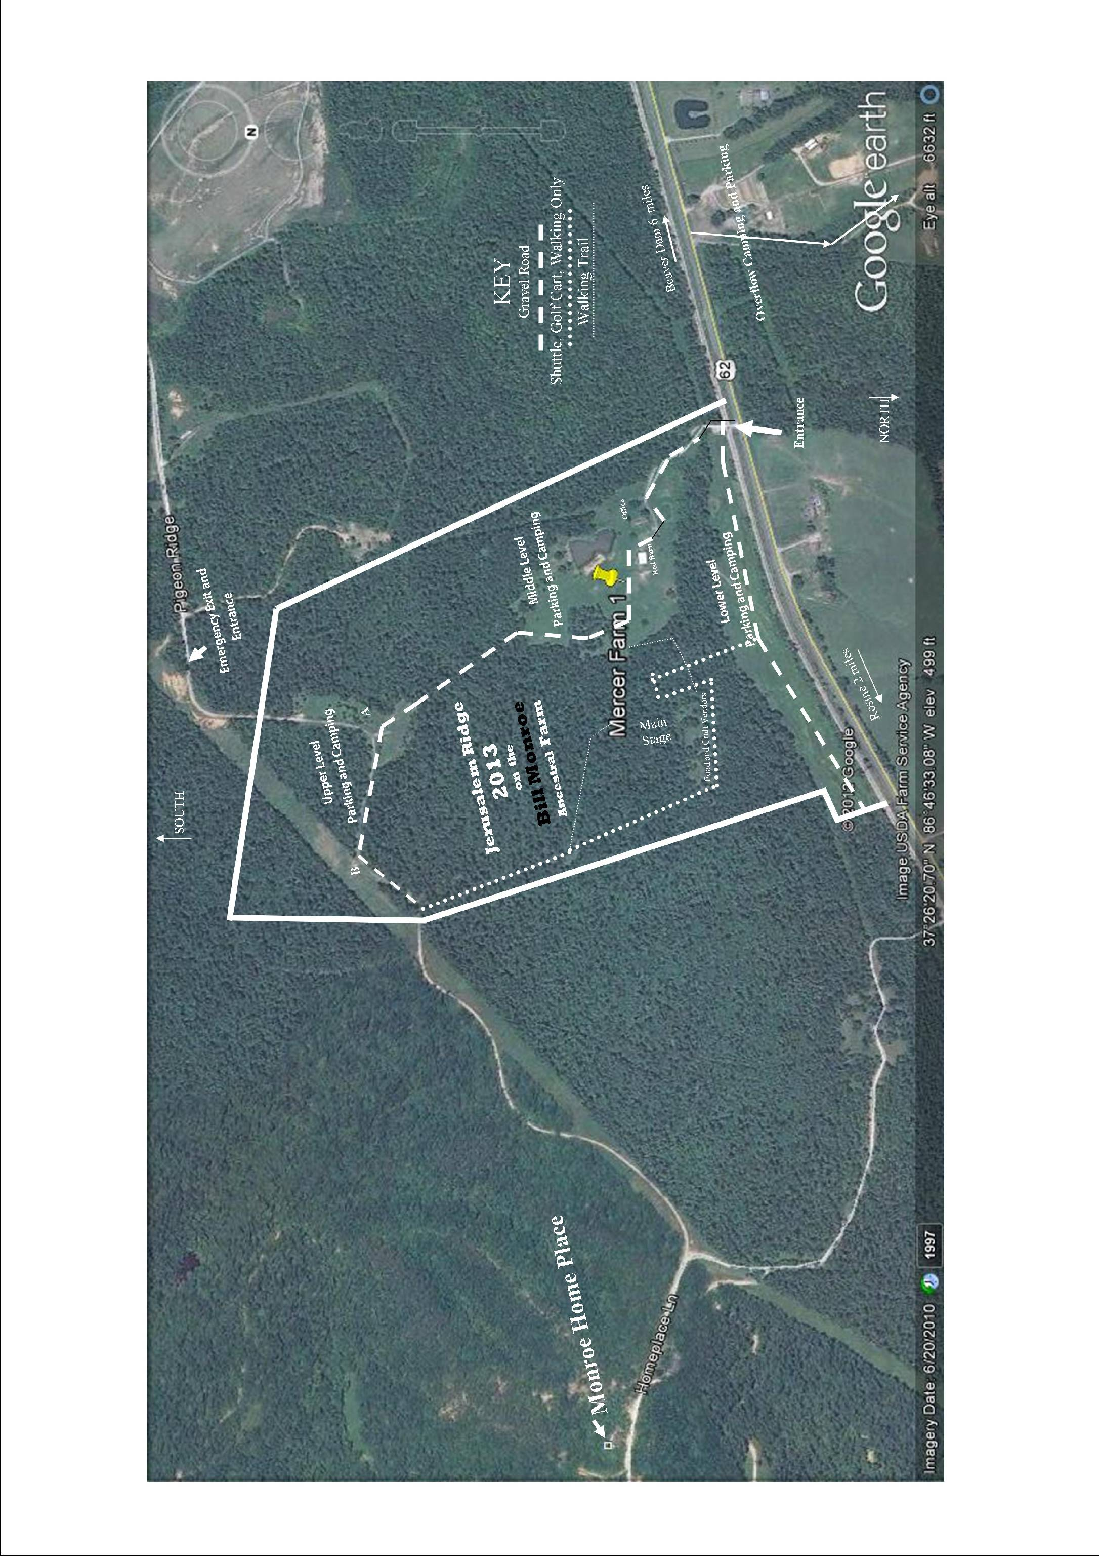
Jerusalem Ridge Farm
West Side
The “Clarence Wilson Farm”

