WELCOME to Kentucky
The Blue Grass State!

Howdy Friends
This is your friends Campbell and Julie Mercer writing to you from high upon Jerusalem Ridge overlooking the town of Rosine, Kentucky. You are living a part of American history this weekend as the Jerusalem Ridge Bluegrass Celebration enlarges and grows to include even more of the ancestral Monroe land that was originally deeded to Bill Monroe’s great, great, grandfather in 1801 for service to the young United States of America in the Revolutionary War. This part of the farm was even farmed by Uncle Pen and was owned by Pen’s best friend Clarence Wilson. When Bill first added the banjo to the Blue Grass Boys in 1943 he chose Dave “Stringbean” Akeman from Jackson County Kentucky. Bill said later that he added “Stringbean” because he wanted to “include the sound of the 5-string banjo that he heard as a boy growing up on the farm in Kentucky” This farm may have been the first place that Bill heard a five string banjo and Clarence likely was the first banjo player that Bill heard. In Bill’s mind this farm that you are sitting, or standing on, right now may be the birthplace of the bluegrass banjo.
We call Jerusalem Ridge not only the birthplace and boyhood home of famous people like Bill and Charlie Monroe, but also the birthplace of an American art form. When you come to Jerusalem Ridge you will feel and experience the history everywhere you turn. You will see the views and hear the sounds of nature that inspired young Bill. And, you’ll experience the warmth of the Jerusalem Ridge folks.
The Jerusalem Ridge project is run by a very small volunteer army. Today, there is a core of about 15 dedicated folks who have kept the dream of the Rosine Project alive. In addition, there are about 10 wonderful local people who give tours of the birthplace of bluegrass music seven days a week but there is so much to do and we need your help too!
The new park addition is a historical diamond in the rough, but look how beautiful the volunteers have made it this year. We had twelve years to build the Homeplace side of the park…but three years ago we had only 40 days and 40 nights to carve this one from the wilderness. This year the Julie, Joby Miler and the team have been working night and day for the past nine weeks getting ready for the 14th Annual Jerusalem Ridge Bluegrass Celebration. Heartfelt thanks to them, to you who expended so much energy and expense to support our preservation efforts, and to the musicians who keep this precious part of our American culture alive.
We also want to thank the greatest fans in the world who have supported the traditional American Bluegrass music of the Cumberland Highlanders Show for the past 19 years. The outpouring of concern and support has meant so much to the bands, the show, and to our family. Let your voice continue to be heard. Listen for the latest announcements about our TV show from the stage.
God Bless You All,
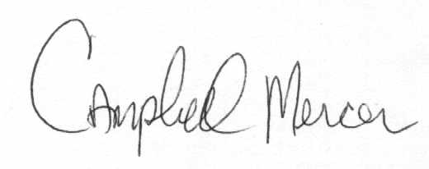
Jerusalem Ridge 2015
A Great American Moment in a Great American Movement1-270-256-1430 or 1-270-315-5151 jerusalemridgefestival.org docmercer@earthlink.net

Bluegrass from its birthplace
Jerusalem Ridge Bluegrass Celebration 2015

Wednesday September 16, 2015

12:00 -3:15 Open Mic with Hosts- Kody Norris, Becky and the Butler County Boys,
3:20 - 4:00 King's Highway
4:05 - 4:55 Larry Gillis and his Swamp Grass Band
5:00 – 5:40 Tommy Brown and the County Line Grass
5:45 – 7:00 Larry Sparks and the Lonesome Ramblers
7:05 – 8:05 The Karl Shiflett and Big Country Show
8:10 - 8:40 Cumberland Lowlanders
Songwriters workshop- 9:00 PM- Red Barn with William Whitacre

Thursday September 17, 2015
10:00 - 10:10 Color Guard, National Anthem, Invocation
10:15 - 10:40 Cumberland Highlanders
10:45 - 11:05 Phillip Steinmetz and his Sunny Tennesseans
11:10 - 11:35 Bluegrass Young’uns, Ohio County Grade School
11:45 - 12:25 Kings Highway
12:30 – 1:10 Phillip Steinmetz and his Sunny Tennesseans
1:15 - 2:05 Larry Efaw & the Bluegrass Mountaineers
2:10 - 3:05 David Davis and the Warrior River Boys
3:10 - 4:00 Alan Sibley and the Magnolia Ramblers
4:05 - 4:55 The Karl Shiflett and Big Country Show
5:00 - 6:15 Larry Sparks and His Lonesome Ramblers
6:20 - 7:05 Larry Gillis and His Hard Driving Swamp Grass Band
7:10 - 7:55 The Cumberland Highlanders
9:00 - 8:05 The Cumberland Highlanders and Guests
8:10 - 8:55 Tommy Brown and County Line Grass
Songwriters workshop- 9:30 PM- Red Barn with William Whitacre

This world class event would not occur without the talent and love of the participating musicians. These are the best of the best when it comes to picking and singing Real Bluegrass Music. Shake their hands, buy their music, and tell them how much we all appreciate them.
The Jerusalem Ridge Bluegrass Celebration could not take place without this team of wonderful, and generous volunteers. Special thanks to the festival prep crew that has worked for many weeks getting the farm ready- Including Joby Miller, J.D. Miller, David Earl Miller, Emmett Stevenson, David Hall, Ron and Cindy Tucker, Ralph Haycraft, Joyce Ray Daugherty, with the help of Kenny Wathen, Don Coppage, Jim Wimsatt, Clarence and Teresa Cotton, Barb and Joe Magee, The Filbacks, Kody Norris, William Whitacre, Mike and Priscilla Dye, Jerry Cannon, Vickie Miller, Nikki Skaggs, Mark Allen, Jill and Ray Align, Pete and Mary Lou Carmen, Vern and Mary, Jim the Vendor, our dear Mississippi friends- the Collins, Tribbles and others, Kendall and Anna, and the 200+ other volunteers working the festival now that it has started If anyone was not mentioned, it was not intentional, and we love you!!

Friday September 18, 2015
Songwriters workshop- 9:00 AM- Behind main stage with William Whitacre

9:00 - 10:00 Rooster Crow Warm-Up
10:05 - 10:45 Cumberland Highlanders
10:47 - 11:00 Cumberland Highlanders Guests
11:05 - 11:35 Phillip Akemon
11:40 - 12:10 Glenville State College Bluegrass Band
12:15 - 12:55 Price Sisters
1:00 - 1:40 Tommy Brown and County Line Grass
1:45 - 2:25 Kody Norris and the Watauga Mountain Boys
2:30 - 3:15 Larry Gillis & His Hard Driving Swampgrass Band
3:20 - 4:05 Ricky Prater and the Midnight Travelers
4:10 – 4:55 Sammy Adkins and the Sandy Hook Mountain Boys
5:00 - 5:50 Gary Brewer and the Kentucky Ramblers
5:55 - 6:45 Goldwing Express
6:50 – 7:35 Phillip Steinmetz and His Sunny Tennesseans
7:40 - 8:25 Kings Highway with Carolina Rose
8:30 – 9:10 Cumberland Highlanders
9:10 - 9:30 Cumberland Highlander Guests

Saturday September 19, 2015
9:00 - 9:55 Rooster Crow Warm-Up
10:00 - 10:35 Shane Adkins
10:40 - 11:25 Cumberland Highlanders and The Chunn Family
11:30 - 11:40 Guests of the Cumberland Highlanders
11:45 - 12:25 The RidgeRunners Gospel
12:30 - 1:10 Finley River Boys with Brett Dudenhoeffer
1:15 - 1:55 Phillip Steinmetz and his Sunny Tennesseans
2:00 - 2:40 The River Ramblers
2:45 - 3:00 Square Dancing and Fiddler's Roll Call
3:05 - 3:25 Shane Adkins
3:30 - 4:20 David Leatherman and Stone County
4:25 - 5:15 Sammy Adkins and the Sandy Hook Mountain Boys
5:20 - 6:10 Kody Norris and The Watauga Mountain Boys
6:15 -7:15 Clarence Kelly and Nu Cut Road
7:20 - 8-10 Melvin Goins and the Windy Mountain Boys
8:15 - 9:20 The Cumberland Highlanders

TV Fact- The Cumberland Highlanders Show has been on for 19 years and produced 660+ episodes. The show has more viewers than CNN on Saturday night and along with Hee-Haw has led in the ratings on RFD-TV at various times! All TV production and editing is paid for by the Mercer Family. Any corporate advertising, revenue goes to the TV stations. This amounts to thousands of dollars per month expense for Doc and Julie to keep this great programming coming into your homes every week. Your ticket purchase to The Jerusalem Ridge Bluegrass Celebration is the only support we have but ticket revenues don’t cover what it cost to produce this important TV show. If you would like to help the Cumberland Highlanders Show and the festival financially during the year call or write to us. We appreciate it! Doc

Keeping the Dream Alive
Jerusalem Ridge Bluegrass Celebration 2015

Sunday, September 20, 2015
10:00 - 10:50 Graveside Service and Gospel Singing
11:05 - 11:35 Church Service on the stage in the Wildwood
11:40 - 12:10 Gospel Singing and Sing- Along with Doc, Julie, Shane, and others
12:15 –12:55 Finley River Boys with Brett Dudenhoeffer
1:00 – 1:40 Shane Adkins
1:45 - 2:35 King's Highway with Special Guest Carolina Rose
2:40 - 3:20 Cumberland Highlanders
3:25 - 4:05 The Rosine Diners Club
4:10 – 4:55 David Leatherman
5:00 – 5:50 Melvin Goins and the Windy Mountain Boys
5:55 – 7:10 Finale with the Cumberland Highlanders and Guests

Festival Rules:
- Keep Jerusalem Ridge wholesome – No alcohol or illegal substances are allowed. And, Ohio County is a dry county.
- Please realize that Jerusalem Ridge is operated by volunteers. Please treat them kindly. Many of them don’t even get time to listen to the music on the stage.
- Drive very slowly. Be sure to always stay to the right! Watch out for blind curves.
- If you leave your chair for extended periods expect folks needing a better view to plop down in it. They’ll be happy to move when you return.
- Please do not smoke in the concert, stage, backstage, and work shop areas.
- All campers should register with attendant before setting up. Please notify attendant if you think you have a loud generator. Quiet generators, not necessarily whisper quiet, but generators rated in the 60-69 decibel range are best.
- Please follow instructions of parking attendant. We must keep access open for emergency vehicles.
- Keep pets leashed. Friendly pets only. Please clean up after them.
- You may be on TV. It is assumed that you are agreeable to this. “Hot Set”
- Have a lot of fun!

RV Dumping $15.00 and Water Tank Refill $20.00 (Different Truck )
Call the number below when you need these services
270-685-2888

Special Thanks to
The volunteers and donors who kept the dream alive
30 Greatest Bluegrass Bands in the world
Allen Logging and Chipping
Jimmy Smith Trucking
South Central Bank
Clean Green
RFD-TV
Lizzie Lewis
The MC Team
J and J Towing
Anderson Electric
D & S Construction
Brother Mike Taylor
Jerry and Diana Cannon
Dickey and Janice House
The Owensboro Animal Hospital
Thrifty Bargain Barn of Fordsville
Monroe Home Place Tour Guides and Volunteers
And to the fans who love and support this music and its musicians

JERUSALEM RIDGE 2015 OHIO COUNTY PARK SHUTTLE SCHEDULE For help call 270-256-2550
Wednesday thru Sunday
Leave County Park Leave Jerusalem Ridge
8:00 A.M. 9:00 A.M.
8:30 10:00
9:00 12:00
9:30 1:00 P.M.
10:00 2:00
11:00 3:30
12 Noon 5:00
1:00 5:30
2:00 6:30
4:00 7::30
5:30 8:30
6:00 After last show
SUNDAY MORNING GRAVESIDE SERVICE
Shuttles will be available at the Lower Field at Jerusalem Ridge boarding area starting at approximately 9:00 Sunday morning to pick up people going to the Bill Monroe Graveside Service at the Rosine Cemetery. They will make as many trips as necessary to get all that want to attend to the site and return.
PARK SUNDAY SCHEDULE
Busses will be available at the Ohio County Park at 8:15 to take folks to the Graveside Service at the Rosine Cemetery and to drop off those who want to remain on Jerusalem Ridge. The regular bus schedule to the Ridge will resume after the service at approximately 11:30 and will run until after the Finale in the evening.
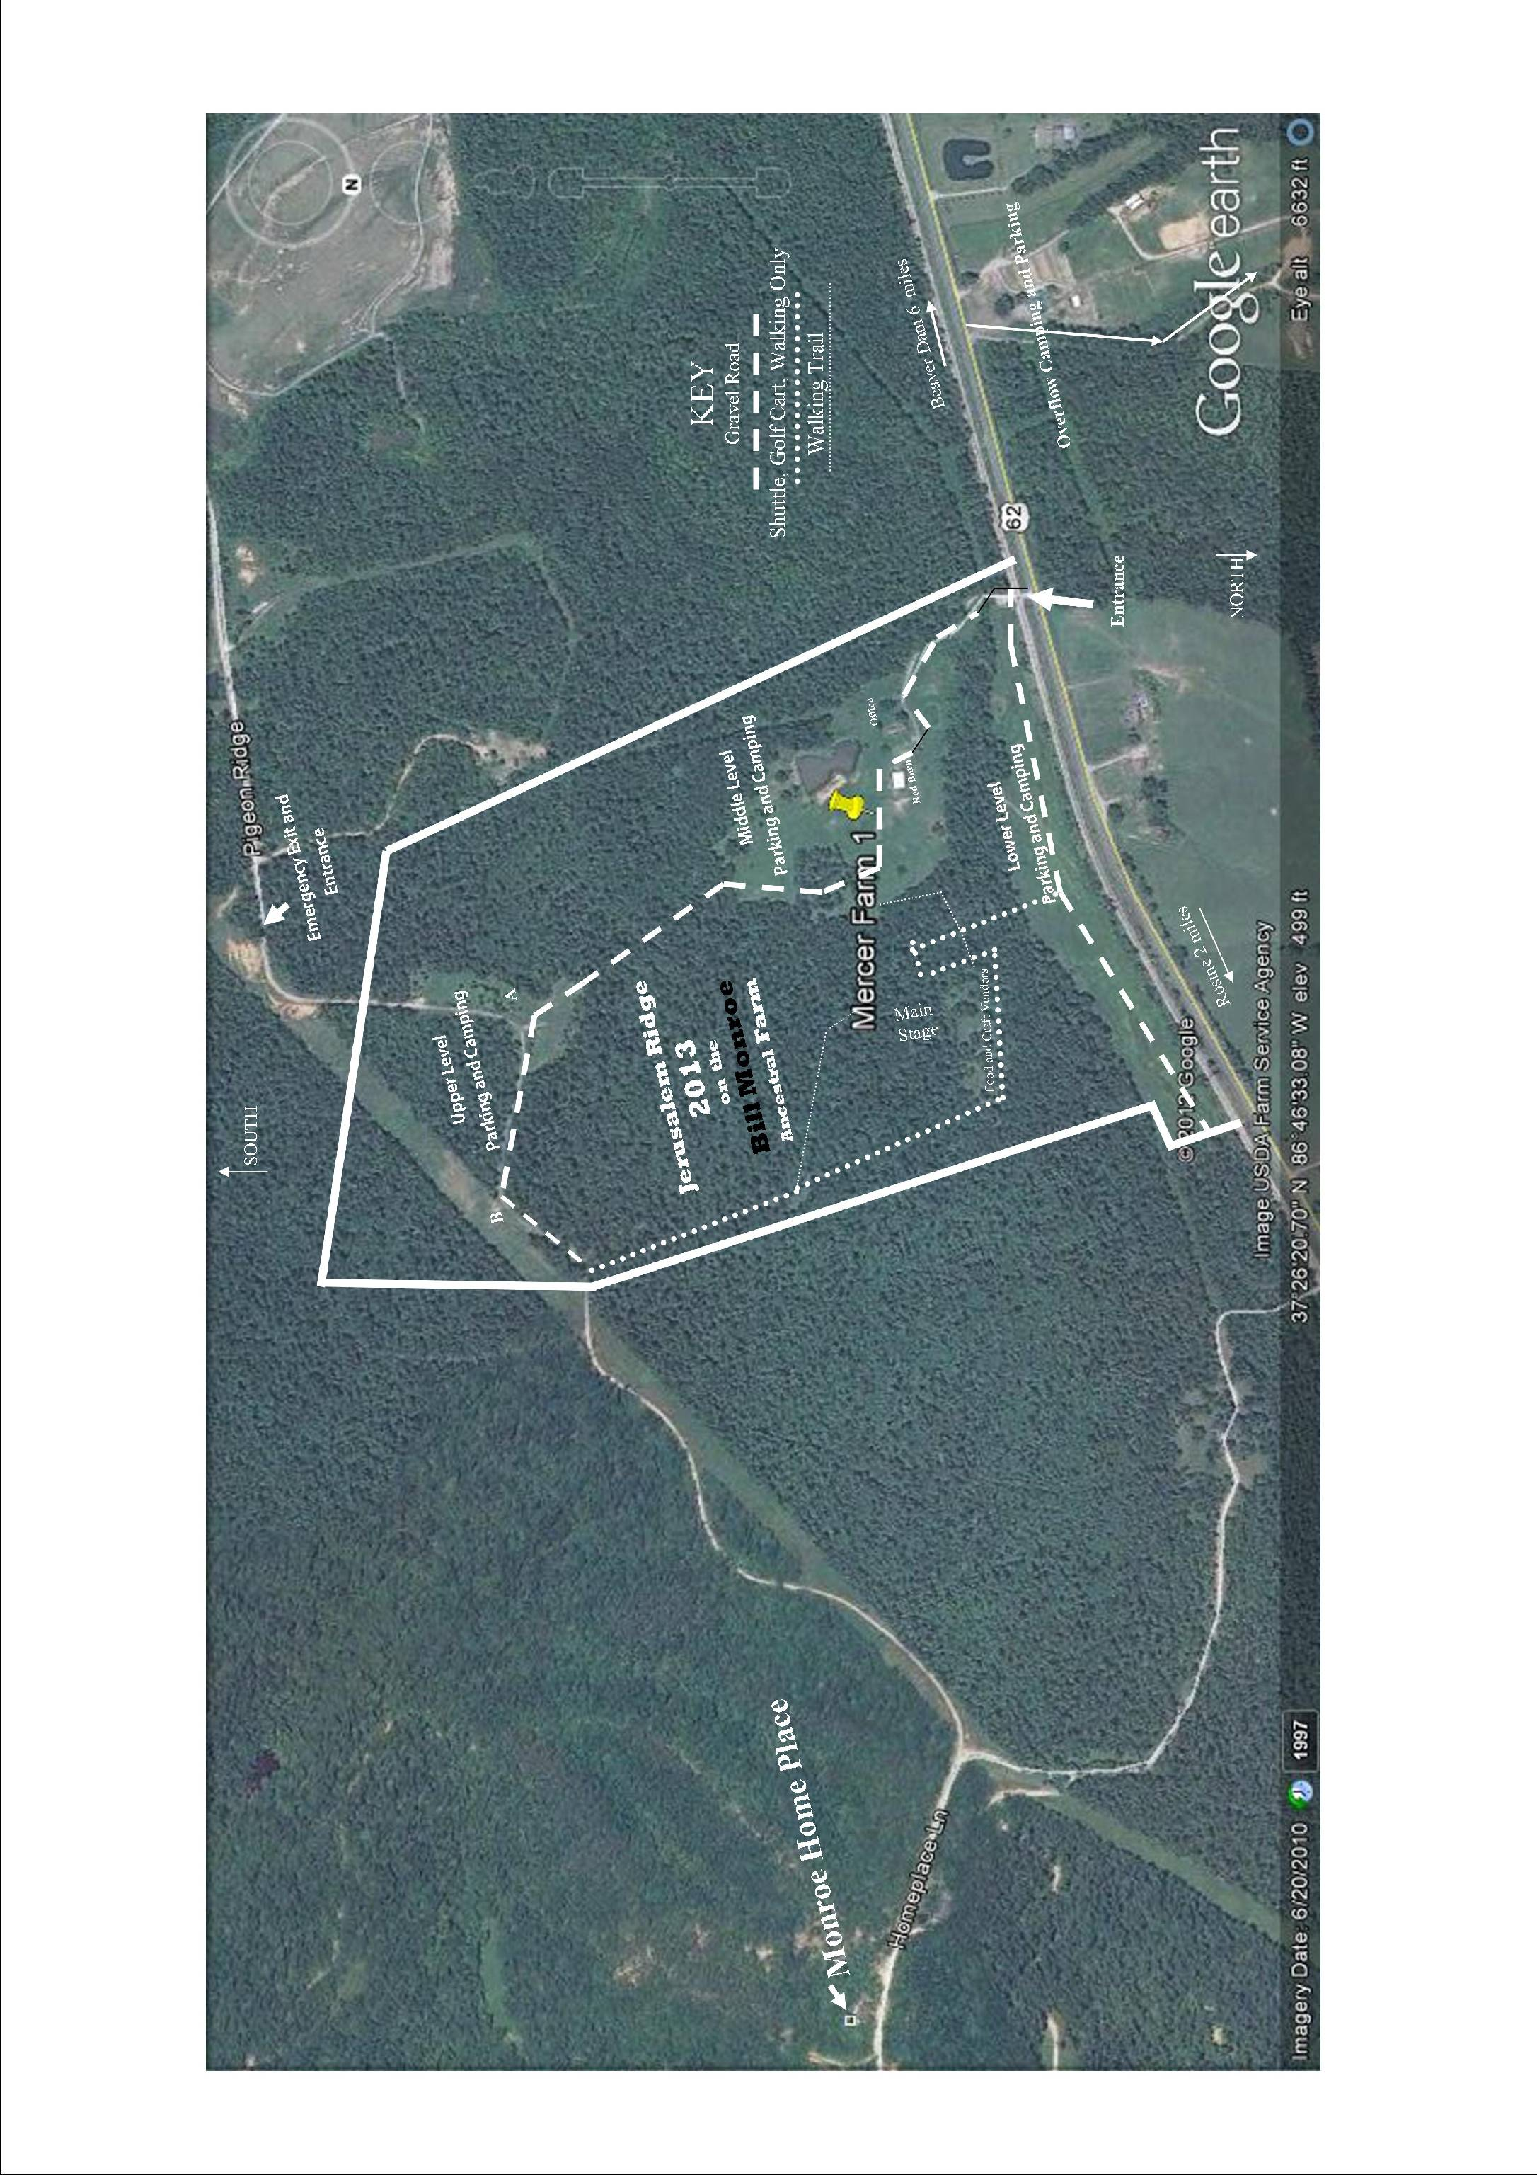
JRBC 2015
Jerusalem Ridge Farm
West Side
The “Clarence Wilson Farm”

